Using PE:J - A Banking Application

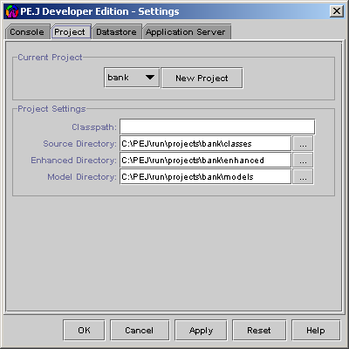

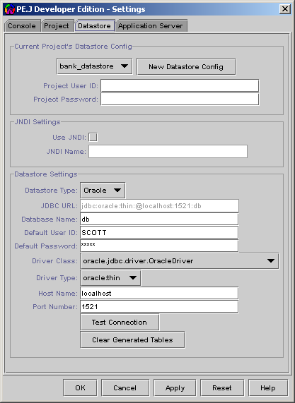

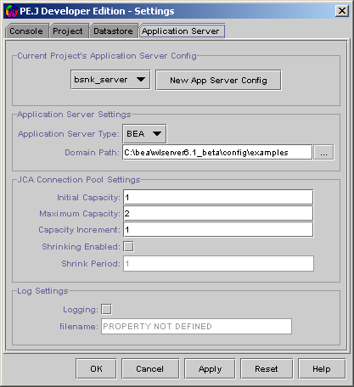

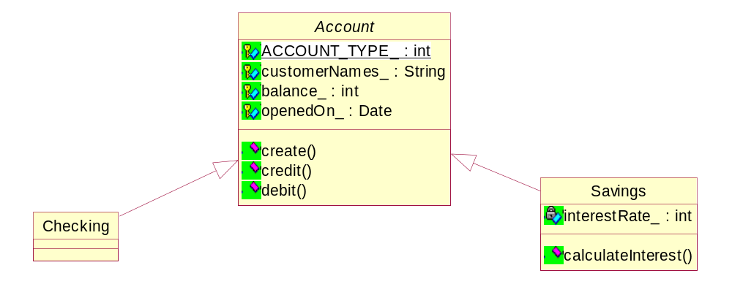

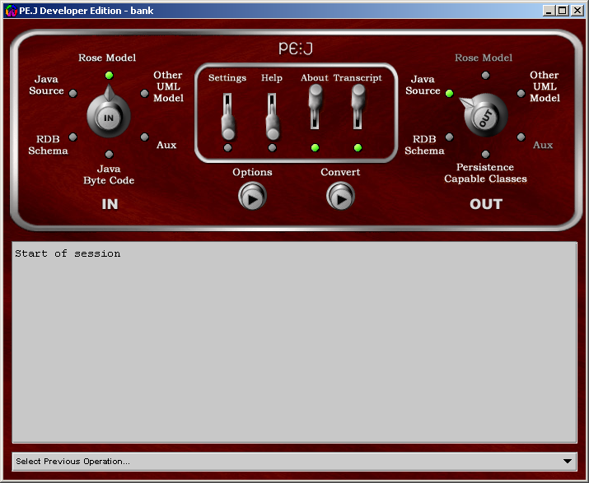

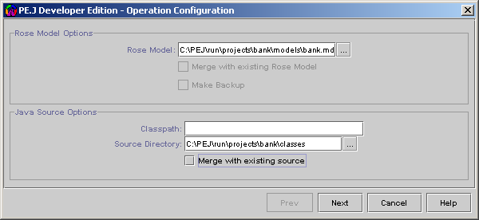

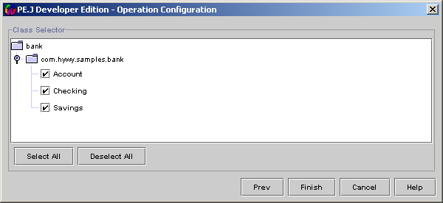

package com.hywy.samples.bank;

import java.util.Date;
import java.util.Calendar;
import java.util.TimeZone;

/**
* Class Description for Account.java
*
* @author: Administrator
* @created date: Apr 2, 2002
* @last modified date:
* @version:
*
*/
public class Account {

/** Attribute ACCOUNT_TYPE_ */
protected int ACCOUNT_TYPE_ ;

/** Attribute customerNames_ */
protected java.lang.String customerNames_ ;

/** Attribute balance_ */
protected int balance_ ;

/** Attribute openedOn_ */
protected java.util.Date openedOn_ ;

/** Constructor */
public Account() {
super();
}

/** Methods Description */
public int create(java.lang.String customerNames, int startingBalance) {
///////////////////////////////////////////
//// Start of User's Business Logic ////
///////////////////////////////////////////
this.customerNames_ = customerNames;
this.balance_ = startingBalance;
this.openedOn_ = Calendar.getInstance(TimeZone.getTimeZone("GMT")) .getTime();
return this.balance_;
///////////////////////////////////////////
//// End of User's Business Logic ////
///////////////////////////////////////////
}

/** Methods Description */
public int credit(int amount) {
///////////////////////////////////////////
//// Start of User's Business Logic ////
///////////////////////////////////////////
this.balance_ += amount;
return this.balance_;
///////////////////////////////////////////
//// End of User's Business Logic ////
///////////////////////////////////////////
}

/** Methods Description */
public int debit(int amount) {
///////////////////////////////////////////
//// Start of User's Business Logic ////
///////////////////////////////////////////
this.balance_ -= amount;
return this.balance_;
///////////////////////////////////////////
//// End of User's Business Logic ////
///////////////////////////////////////////
}

/** Setter Method for field --> ACCOUNT_TYPE_*/
public void setACCOUNT_TYPE_( int newACCOUNT_TYPE_ ) {
ACCOUNT_TYPE_ = newACCOUNT_TYPE_;
}

/** Accessor Method for field --> ACCOUNT_TYPE_ */
public int getACCOUNT_TYPE_( ) {
return ACCOUNT_TYPE_;
}

/** Setter Method for field --> customerNames_*/
public void setCustomerNames_( java.lang.String newCustomerNames_ ) {
customerNames_ = newCustomerNames_;
}

/** Accessor Method for field --> customerNames_ */
public java.lang.String getCustomerNames_( ) {
return customerNames_;
}

/** Setter Method for field --> balance_*/
public void setBalance_( int newBalance_ ) {
balance_ = newBalance_;
}

/** Accessor Method for field --> balance_ */
public int getBalance_( ) {
return balance_;
}

/** Setter Method for field --> openedOn_*/
public void setOpenedOn_( java.util.Date newOpenedOn_ ) {
openedOn_ = newOpenedOn_;
}

/** Accessor Method for field --> openedOn_ */
public java.util.Date getOpenedOn_( ) {
return openedOn_;
}

/** Default toString() method */
public java.lang.String toString( ) {
StringBuffer strBuff = new StringBuffer();

strBuff.append(super.toString());
strBuff.append(" Account: ");
strBuff.append(" ACCOUNT_TYPE_= " + ACCOUNT_TYPE_);
strBuff.append(" customerNames_= " + customerNames_);
strBuff.append(" balance_= " + balance_);
strBuff.append(" openedOn_= " + openedOn_);

return strBuff.toString();
}
}

package com.hywy.samples.bank;

/**
* Class Description for Savings.java
*
* @author: Administrator
* @created date: Apr 2, 2002
* @last modified date:
* @version:
*
*/
public class Savings extends Account {

/** Attribute interestRate_ */
private int interestRate_;

///////////////////////////////////////////
//// Start of User's Business Logic ////
///////////////////////////////////////////
public static int SAVINGS_ACCOUNT_ = 2;
///////////////////////////////////////////
//// End of User's Business Logic ////
///////////////////////////////////////////

/** Constructor */
public Savings() {
super();
///////////////////////////////////////////
//// Start of User's Business Logic ////
///////////////////////////////////////////
ACCOUNT_TYPE_ = SAVINGS_ACCOUNT_;
///////////////////////////////////////////
//// End of User's Business Logic ////
///////////////////////////////////////////
}

/** Methods Description */
public int calculateInterest( ) {
///////////////////////////////////////////
//// Start of User's Business Logic ////
///////////////////////////////////////////
return this.balance_*this.interestRate_/100;
///////////////////////////////////////////
//// End of User's Business Logic ////
///////////////////////////////////////////
}

/** Setter Method for field --> interestRate_*/
public void setInterestRate_(int newInterestRate) {
interestRate_ = newInterestRate;
}

/** Accessor Method for field --> interestRate_ */
public int getInterestRate_() {
return interestRate_;
}

/** Default toString() method */
public java.lang.String toString( ) {
StringBuffer strBuff = new StringBuffer();

strBuff.append(super.toString());
strBuff.append(" Savings: ");
strBuff.append(" interestRate_= " + interestRate_);

return strBuff.toString();
}

/** Setter Method for field --> ACCOUNT_TYPE_*/
public void setACCOUNT_TYPE_(int newACCOUNT_TYPE) {
ACCOUNT_TYPE_ = SAVINGS_ACCOUNT_;
}

/** Accessor Method for field --> ACCOUNT_TYPE_ */
public int getACCOUNT_TYPE_() {
return ACCOUNT_TYPE_;
}

}

package com.hywy.samples.bank;

/**
* Class Description for Checking.java
*
* @author: Administrator
* @created date: Apr 2, 2002
* @last modified date:
* @version:
*
*/
public class Checking extends Account {
///////////////////////////////////////////
//// Start of User's Business Logic ////
///////////////////////////////////////////
public static int CHECKING_ACCOUNT_ = 1;
///////////////////////////////////////////
//// End of User's Business Logic ////
///////////////////////////////////////////

/** Constructor */
public Checking() {
super();
///////////////////////////////////////////
//// Start of User's Business Logic ////
///////////////////////////////////////////
ACCOUNT_TYPE_ = CHECKING_ACCOUNT_;
///////////////////////////////////////////
//// End of User's Business Logic ////
///////////////////////////////////////////
}

/** Default toString() method */
public java.lang.String toString( ) {
///////////////////////////////////////////
//// Start of User's Business Logic ////
///////////////////////////////////////////
return super.toString();
///////////////////////////////////////////
//// End of User's Business Logic ////
///////////////////////////////////////////
}

/** Setter Method for field --> ACCOUNT_TYPE_*/
public void setACCOUNT_TYPE_(int newACCOUNT_TYPE) {
ACCOUNT_TYPE_ = CHECKING_ACCOUNT_;
}

/** Accessor Method for field --> ACCOUNT_TYPE_ */
public int getACCOUNT_TYPE_() {
return ACCOUNT_TYPE_;
}
}

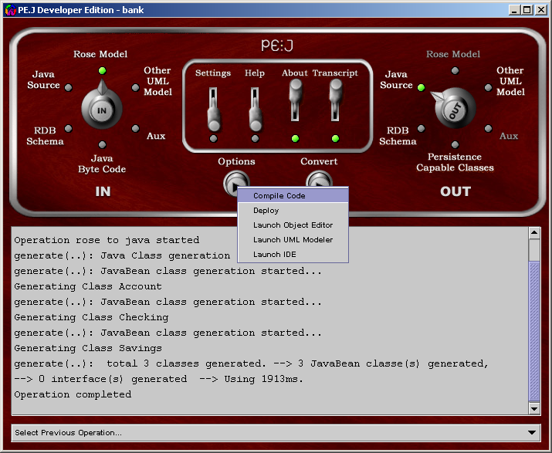

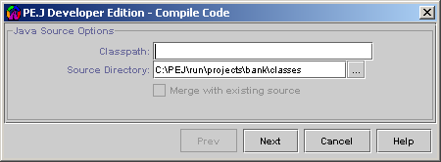

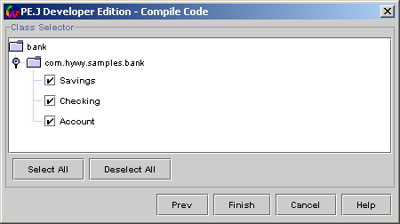

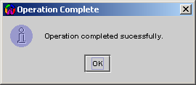

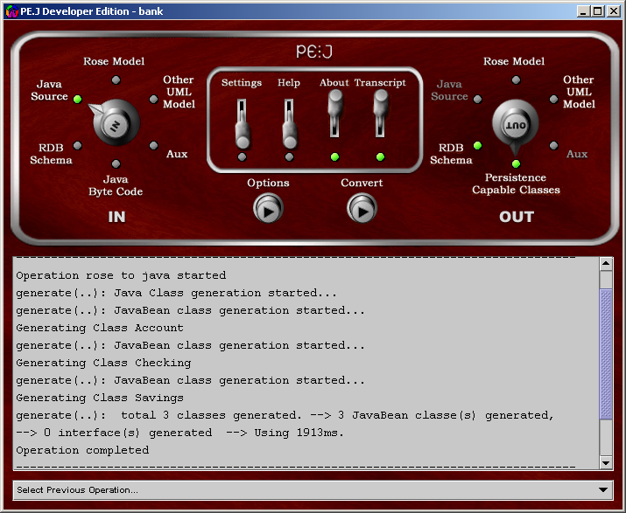

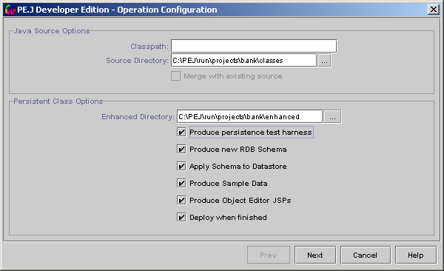

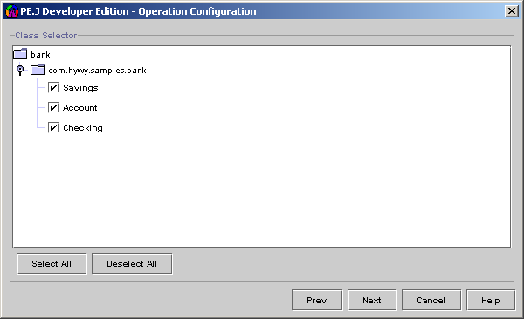

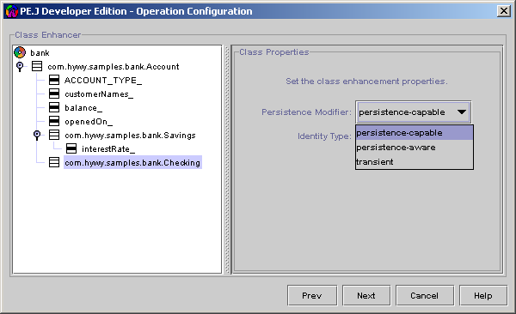

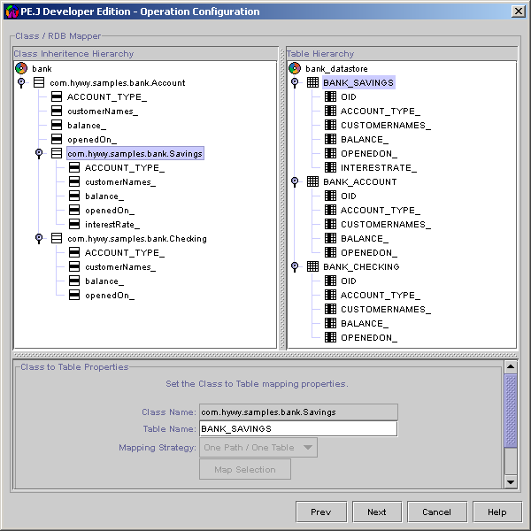

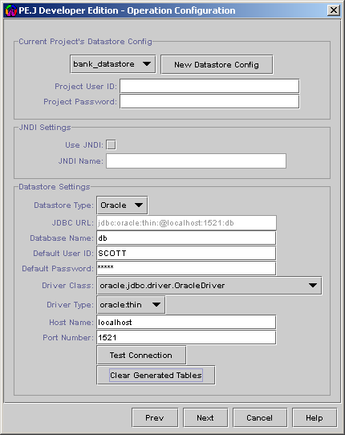

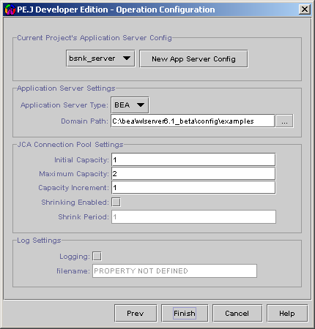

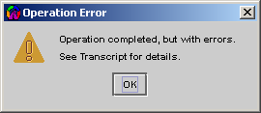

/**
* To Run the Application
* java -classpath
* .;C:\PEJ\lib\jdo.jar;C:\PEJ\lib\j2ee.jar;C:\PEJ\lib\pej.jar;C:\PEJ\lib\tools.jar
* com.hywy.samples.bank.Teller
*/

package com.hywy.samples.bank;

import com.hywy.pej.adapter.JDOAdapter;
import com.hywy.pej.persistence.oidserver.Oid;

// Standard JDO Class Library Imports
import javax.jdo.PersistenceManagerFactory;
import javax.jdo.PersistenceManager;
import javax.jdo.Transaction;
import javax.jdo.Extent;
import javax.jdo.spi.PersistenceCapable;

import junit.framework.TestCase;

import java.util.Date;
import java.util.Iterator;
import java.text.SimpleDateFormat;

import com.hywy.samples.bank.Account;
import com.hywy.samples.bank.Checking;
import com.hywy.samples.bank.Savings;

public class Teller {
/** Project Name that was configured using the Console */
public static final String PROJECT_NAME_ = "bank";

/** Datastore Name that was configured using the Console */
public static final String DATASTORE_NAME_ = "bank_datastore";

/** PMF Object pool initial capacity */
public static final int INITIAL_POOL_CAPACITY_ = 5;

/** PMF Object pool maximum capacity */
public static final int MAXIMUM_POOL_CAPACITY_ = 10;

/** PMF Object pool capacity increment */
public static final int POOL_CAPACITY_INCREMENT_ = 1;

/** PersistenceManagerFactory Object */
PersistenceManagerFactory pmFactory_ = null;

/** A JDOAdapter instance */
JDOAdapter adapter_;

/**
* Retrieve the JDOAdapter that holds the PersistenceManagerFactory Object Pool
*
* @return a JDOAdapter instance that holds the PMF object pool
*/
public JDOAdapter getAdapter() {
return this.adapter_;
}

/**
* Releases the configured PMF and returns it back to the Object Pool,
* so that it can be reused by some other process
*
* @param datastoreName - string denoting the name of the pre-configured datastore
* @param pmFactory - PersistenceManagerFactory object that can be released back to the pool
*/
public void releasePMF(String datastoreName, PersistenceManagerFactory pmFactory) {
this.adapter_.close(datastoreName, pmFactory);
}

/**
* Create a new JDOAdapter
*
*/
public Teller() {
adapter_ = new JDOAdapter(Teller.PROJECT_NAME_,
Teller.INITIAL_POOL_CAPACITY_,
Teller.MAXIMUM_POOL_CAPACITY_,
Teller.POOL_CAPACITY_INCREMENT_);

try{
pmFactory_ = this.getAdapter().obtainPMF(Teller.PROJECT_NAME_,
Teller.DATASTORE_NAME_);
}catch(Exception exception){
exception.printStackTrace();
}
}

/**
* Create Checking or Savings Account
*/
public void createAccount(String customerNames, int startingBalance, boolean isCheckingAccount) {

Account account = null;

if(isCheckingAccount == true) {
account = new Checking();
}
else {
account = new Savings();
((Savings)account).setInterestRate(2);
}
account.create(customerNames, startingBalance);

////////////////////////////////////
// Persform JDO operations
////////////////////////////////////

PersistenceManager pManager = null;
Transaction transaction = null;

try {

// Obtain a Persistence Manager from the Factory Object
pManager = pmFactory_.getPersistenceManager();

// Retrieve a Transaction object from the Persistence Manager
transaction = pManager.currentTransaction();

// Begin a Transaction
transaction.begin();

// Invoke Make Persistent on the object
pManager.makePersistent(account);

// Commit the transaction
transaction.commit();
}catch(Exception exception) {

// Something bad happened.
// If the transaction object was obtained
if(transaction != null) {
// Rollback the transaction
transaction.rollback();
}

exception.printStackTrace();
}
finally {

// Close the Persistence Manager
if(pManager != null) {
pManager.close();
}

// Release the Persistence Manager Factory
if(pmFactory_ != null) {
releasePMF(DATASTORE_NAME_, pmFactory_);
}
}

}

/**
* Transfer Money
*/
public boolean transferMoney(long fromAccountNumber, long toAccountNumber, int amount) {
boolean result = false;
return result;
}

/**
* List out all Checking accounts found
*/
public void listAllCheckingAccounts() {

////////////////////////////////////
// Persform JDO operations
////////////////////////////////////

PersistenceManager pManager = null;
Transaction transaction = null;

try {

// Obtain a Persistence Manager from the Factory Object
pManager = pmFactory_.getPersistenceManager();

Class pcClass = Class.forName("com.hywy.samples.bank.Checking");
Extent extent = pManager.getExtent(pcClass, false) ;

Iterator extentIterator = extent.iterator();
while ( extentIterator.hasNext()) {

PersistenceCapable checkingPC = (PersistenceCapable)extentIterator.next();

Checking checking = (Checking)checkingPC;

Oid currentCheckingOID = null;

currentCheckingOID = (Oid)pManager.getTransactionalObjectId(checkingPC);
System.out.println("Checking Account for :"+currentCheckingOID.toLong());
System.out.println("Details are :"+checkingPC.toString());

}
} catch(Exception exception) {

// Something bad happened.
// If the transaction object was obtained
if(transaction != null) {
// Rollback the transaction
transaction.rollback();
}

exception.printStackTrace();
} finally {

// Close the Persistence Manager
if(pManager != null) {
pManager.close();
}

// Release the Persistence Manager Factory
if(pmFactory_ != null) {
releasePMF(DATASTORE_NAME_, pmFactory_);
}
}
}

/**
* List out all Savings accounts found
*/
public void listAllSavingsAccounts() {

////////////////////////////////////
// Persform JDO operations
////////////////////////////////////

PersistenceManager pManager = null;
Transaction transaction = null;

try {

// Obtain a Persistence Manager from the Factory Object
pManager = pmFactory_.getPersistenceManager();

Class pcClass = Class.forName("com.hywy.samples.bank.Savings");
Extent extent = pManager.getExtent(pcClass, false) ;

Iterator extentIterator = extent.iterator();
while ( extentIterator.hasNext()) {

PersistenceCapable savingsPC = (PersistenceCapable) extentIterator.next();

Savings savings = (Savings)savingsPC;

Oid currentSavingsOID = null;

currentSavingsOID = (Oid)pManager.getTransactionalObjectId(savingsPC);
System.out.println("Savings Account for :"+currentSavingsOID.toLong());
System.out.println("Details are :"+savingsPC.toString());

}
} catch(Exception exception) {

// Something bad happened.
// If the transaction object was obtained
if(transaction != null) {
// Rollback the transaction
transaction.rollback();
}

exception.printStackTrace();
} finally {

// Close the Persistence Manager
if(pManager != null) {
pManager.close();
}

// Release the Persistence Manager Factory
if(pmFactory_ != null) {
releasePMF(DATASTORE_NAME_, pmFactory_);
}
}
}

public static void main(String [] args) {
Teller teller = new Teller();
teller.createAccount("Gopalan Suresh Raj", 10000000, true);
teller.createAccount("Athul Suresh Raj", 20000000, true);

teller.createAccount("Gopalan Suresh Raj", 910000000, false);
teller.createAccount("Athul Suresh Raj", 2000000000, false);

teller.listAllCheckingAccounts();
teller.listAllSavingsAccounts();
}

}

<?xml version="1.0" encoding="UTF-8"?>
<project basedir="C:\PEJ\run\projects\bank\enhanced" default="compile" name="PEJ-DE">
<target name="compile">
<javac debug="on" destdir="C:\PEJ\run\projects\bank\enhanced" srcdir=".">
<classpath>
<pathelement location="C:\PEJ/lib/jdo.jar">
</pathelement>
<pathelement location="C:\PEJ/lib/j2ee.jar">
</pathelement>
<pathelement location="C:\PEJ/lib/pej.jar">
</pathelement>
<pathelement location="${JAVA_HOME}/lib/tools.jar">
</pathelement>
<pathelement location="C:\PEJ\run\projects\bank\enhanced">
</pathelement>
</classpath>
<include name="com/hywy/samples/bank/Savings.java">
</include>
<include name="com/hywy/samples/bank/Account.java">
</include>
<include name="com/hywy/samples/bank/Checking.java">
</include>
<include name="com/hywy/samples/bank/Teller.java">
</include>
</javac>
</target>
</project>



